**Light, Urban Planning, and Climate Change**

|  |
| --- |
| **Lesson Plan for Grades: High School (10th-12th Grade)**  **Length of Lesson: 4-5 Class periods** |
| **Authored by:** UT Environmental Science Institute (Erick Jones)  **Date created:** 12/01/2018 |
| **Subject area/course:**   * Physics, Economics |
| **TEKS/SEs:**  **§112.38. Integrated Physics and Chemistry**  (4) Science concepts. The student knows concepts of force and motion evident in everyday life. The student is expected to:   * (A) describe and calculate an object's motion in terms of position, displacement, speed, and acceleration; |

**Questions to Answer (Objectives)**

1. How do you get citizens to not cause traffic jams?
2. How do you get citizens to not pollute as much?
3. What is light and how do we use it?
4. What is the greenhouse effect and how does it influence the Earth?
5. How does income, trade, traffic, and other city decisions affect population and carbon intensity?

**Lesson Plan Outline**

**Activity / Lesson 1**

**Main Points**

Recall your ideal city

Traffic Flow is an explicitly function of only follow distance

Average Speed affected by physics.

Supply and Demand Lessons

**Introduce New Topics**

Safety of light rail.

Trackless tram

LP Main Objectives

Incentive your idea vs what they already have

**LP Lesson**

Make $2 per bushel of apples $4 per bushel of mangos

Have a truck that can take 100 bushels of either fruit to market

Have space for up to 120 apples on your land or a total of 72 mangos

Max profit 2A + 3M

A+M <= 100

3A+5M <= 360

Objective – max profit

Decision Variables – how many bushels of apples or mangos to grow

Parameters – total amount of bushels that you can grow, how much space you land has

Answer: 70 A; 30 M

Sensitivity Analysis

What happens if you make $4/ mango

72 M

Or if you only have space for 80

20 A, 60 M

Or if you only grow 100 apples and 60 mangos

100 A

More or less parking

Gas $2 / gal; 24 miles/gal

Maintenance: $0.05/ mile

Time: 30 mph normal; 20 mph traffic times

Average distance to work: 15 miles

Work: 20 times a month

Worth of time: $5/hour

Discount factor to current decision: 0.90

**The actual model**

Baseline: 600 miles to work every month. 25 gallons every month. Time 30 hours in car.

$50 for gas, $30 for maintenance, $150 for time.

$230 and any alternative would have to be $207 or cheaper to be accepted if nothing changed.

Citizens are willing to pay $280 max for transportation, anything more riots. Anything less they will throw a benevolent dictator day.

Case Study

Assume your bus is $3 round trip. Average speed 20 miles per hour.

$60 for trips. 30 hours on bus. $150 for time. $210 total not low enough for citizens to want to switch.

But what if you started charging $2 for parking as well. Then their cost would be $270 for their normal method.  And $270 * .9 = $243 which is more than the bus cost. So you have an option below the riot cost and the citizens would pick your option before theres.

Need your cost in time and cost per mile.

**Activity / Lesson 2**

Jeopardy – Planet Texas

**Activity / Lesson 3**

**Closer to Monopoly / Try to control portions of light**

Game give each team 1 card from each of these sectors. You split the revenue evenly between each card.

However, once you have 3 of a light source you get 90% of the revenue and the remaining card only gets 10%.

Cell phone companies need to put $10 million in telecom infrastructure.

Nuclear Plants need to put $5 million in waste. Unless you own the waste.

All other tech is stand alone.

Can Use a Deck of Cards. In fact its easier to use cards.

Keep Score on the Board.

Do a round where you don’t tell the students the revenue of each sector.

Do a quiz to determine the two groups who get the waste management and telecommunication infrastructure cards.

I.e. place different types of light on the appropriate part of the spectrum

This forces the teams to trade otherwise the team who received telecommunication infrastructure would win (note still don’t tell them how much that is worth.)

Give the teams about 10 mins to trade.

Repeat game after telling each team how much each sector is worth. See if the strategy changes.

|  |  |  |  |  |
| --- | --- | --- | --- | --- |
| Light | Game Revenue | 1 Card | 3 Cards (90%) | 1 Card (10%) |
| Cell Phone (2) | $160 | $40 | $144 | $16 |
| Nuclear Power Plant (3) | $80 | $20 | $72 | $8 |
| X-Ray/CT Scans (4) | $60 | $15 | $54 | $6 |
| Broadcast TV (5) | $40 | $10 | $36 | $4 |
| WiFi / RFID / IOT (6) | $40 | $10 | $36 | $4 |
| 5G (7) | $30 | $8 | $27 | $3 |
| GPS (8) | $25 | $6 | $22.5 | $2.5 |
| Telecom. Infrastructure (Jack) | $25 | $25 | N/A | N/A |
| AM/FM Radio  (9) | $20 | $5 | $18 | $2 |
| Nuclear Medicine (10) | $20 | $5 | $18 | $2 |
| Nuclear Waste Mgmt. (Ace) | $10 | $10 | N/A | N/A |

c= lambda*f

E = h * f = h * c / lambda

**Sources**

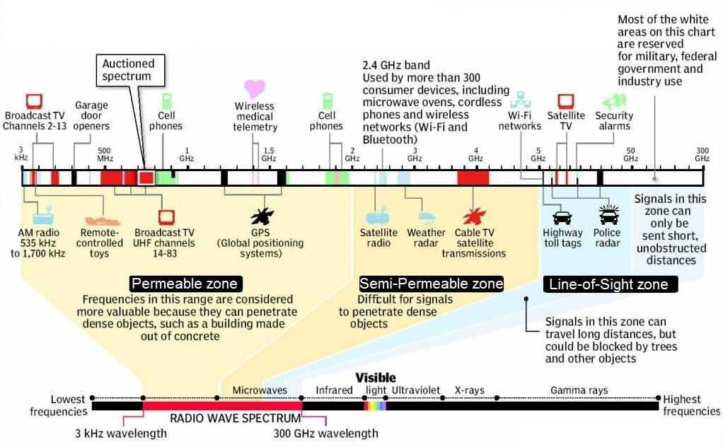

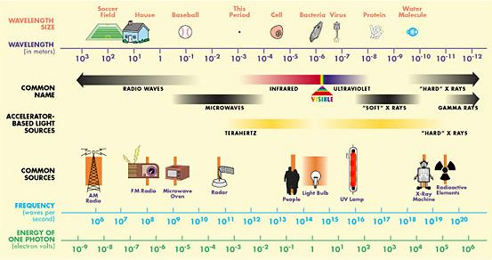

AM Radio / FM Radio ($22 billion)

<http://www.insideradio.com/free/radio-s-streaming-ad-revenue-to-hit-billion-by/article_db9ff3f2-6959-11e8-b7d0-ab466f7bba4d.html>

Broadcast Television ($40 billion)

<https://www.broadcastingcable.com/news/tv-revenue-expected-to-dip-in-record-setting-year-for-ads>

Cell Phone ($200 billion)

<https://cbpp.georgetown.edu/sites/default/files/Policy%20Paper%20-%20Kovacs%20-%20Wireless%20Competition%202018-08.pdf>

GPS ($25 billion)

<https://www.businesswire.com/news/home/20161018006653/en/Global-GPS-Market-2016-2022-Market-Generated-Revenue>

RFID technology ($13 billion)

<https://www.reportlinker.com/p05503702/Radio-Frequency-Identification-Market-Revenue-to-Grow-at-a-CAGR-of-14-5-During-Driven-by-Integrating-RFID-Technology-with-IoT-and-Big-Data-Platforms-for-Real-time-Data-Access.html>

5G signals ($30 billion)

<https://telecom.economictimes.indiatimes.com/news/5g-to-generate-usd-27-3-bn-revenue-potential-by-2026/61689424>

X-Rays / CAT Scan ($56 billion)

https://www.grandviewresearch.com/press-release/medical-imaging-systems

Nuclear Medicine (gamma rays) ($15.2 billion)

<https://www.grandviewresearch.com/press-release/global-nuclear-medicines-market>

<https://www.mapw.org.au/files/downloads/Nuclear%20medicine%20fact%20sheet.pdf>

Nuclear Power Plant (gamma rays) ($80 billion) (805 billion kWh)

<http://www.world-nuclear.org/information-library/country-profiles/countries-t-z/usa-nuclear-power.aspx>

Nuclear Waste Management ($6 billion)

<https://www.prnewswire.com/news-releases/nuclear-waste-management-market-to-account-for-us563-billion-in-revenue-by-2024-influx-of-investments-to-support-growth-tmr-580244921.html>

Telecommunications Infrastructure ($25 billion)

**Activity / Lesson 4**

Higher energy waves can kill you with high dice rolls 4-6.

Medium energy waves can kill you with medium dice rolls 2 and 3

Low energy waves can kill you only with a 1.

However, the kill roll only works after you have the card for 1 turn for high energy, 2 turns for medium energy, and 3 turns for low energy.

Each group starts with one of each. And can trade with other groups. But every turn you have to give and receive a type of energy from each group.

Needs a proper physics introduction why these waves are dangerous.

*Looking for a proper physics feel to this.*

*Last game was too much “economics”*

Bring people into it

All part of the same thing change the wavelengths or frequencies.

How did they figure it out Maxwell, Einstein give humanity to the equations?

Play with different frequencies f

Some of the divisions of light are determined by nature others are determined by society i.e. visible light vs. military spectrum

UV comes in infrared comes off what happens to the energy (carbon absorbs the energy)

Draw the waves of light

Fill in the light spectrum

Amplitutde gives data

Why the sun’s light can go in but not out?

The light coming out of your lights is the same as your cell phone signal

**Activity / Lesson 5**

Terraforming Competition

You are humans from the future whose groups are charged with terraforming various planets.

As you have learned in your various advanced science classes CO2 concentration has a strong effect on life and biodiversity of your planets. Rather than trying to win the evolution jackpot you seek to control your GHG concentration. However, you peers are doing the same thing. The only solution is sabotage.

**Setup/Background**

The game consists of 3 rounds with 4 turns in each round. It goes in a snake like order i.e. the first team goes first in the first round and last in the second round.

You start with chips worth 30 CO2 concentration >>> 300 ppm. You start with 3 blue chips (5 points a piece can’t be traded), 4 red chips (worth 2 points a piece can be traded), and 7 white chips (worth 1 point a piece can be traded). You will receive 5 points for GHG in range 20-25, 4 points for 25-30, 3 points for 30-35, 2 points for 35-40, and 1 point for anything higher than 40. You score each team at the end of each round.

**In your turn**

You can convert exactly 5 CO2 points (white and red chips only) for a blue chip to stabilize the carbon on your planet also removing the CO2 from the game.

You can send up to 9 CO2 points to any team.

Note you do not have to trade or convert.

**Special Case**

In round 3 you can turn give the accountant 4 blue chips and get 3 blue chips in return.

**Summary**

That’s it. You have 4 turns to trade around tradable CO2 or convert it to blue chips. You keep score at the end of each round. Thus you will have three scores to add up at the end. You do not reset at the end of each round.

**Activity / Lesson 6**

**Final City Building**

Go over Modeling Assignment 4. Show what a report looks like IMRAD format. And mention it was just a B+ because the methods section wasn’t fleshed out enough because I procrastinated.

Start with a Quiz to see who gets to pick what city first

<http://r.mail.quizizz.com/tr/cl/tz6iW4xAzO8MNIfoOul1iJiSkTD3OMshSGOz1Gsn7j9LsyIK5DLJ2VbkUBTDMATUXTV1OIiM9jV_RjekGTOEFCcEwnS1527fS3VugDuS_hr8DlhinZZAU8ZIl2JwSblwE6ZcNJdkciVhjUP3L5Lv99S-wFqCY2TMsKjnHhYRLB9Ev5SHzt5Pk9MDsRiQ7nEvwVnl3AD6rCf0QgC0xVM-jlnGouROH40x4IPGsjZg4ib0Ou3gbYTCZhL6lWQe8a9eiLvq_YFUuU9PbiUN9WkrytsnjKu8lLwCYhDZ4U5f2Vk5ekTnV2HREhiFiamCqXCImozYG2QI9-n-BZL48b_lRA>

3 types of Currency (Capital, Labor, Materials)

Can build anything with some combination of those things.

4 Types of Cities

Capital Intensive (12 coins)

Labor Intensive (12 coins)

Material Intensive (12 coins)

Balanced ( 4 of each)

Can trade amongst each other.

Can create you own plans as long as I can implement them in my program.

Benefits can be stacked.

Some examples

Roads (2 capital, 2 labor, 2 material)

-lowers travel cost by 15%

Train (3 capital, 3 labor, 3 material)

-lowers travel cost by 10%

-lowers emissions by 10%

Tax Cuts (2 capital)

-Increases income by 15%

Parks ( 2 labor, 1 capital)

-raises amenity by 10%

Stadium ( 2 labor, 2 capital, 2 material)

-raises amenity level by 25%

Electric Vehicle Subsidy (4 capital)

-lowers emissions by 15%

**Activity / Lesson 7**

**Flotilla City Game**

Expanding on the last city game this time I participate as a banking country with a strong navy.

I am the global ledger that keeps track of trades and capital that is produced.

However, I do not keep track of the messages between the cities.

All the other cities are more or less carbon neutral, they have mostly electric cars, their buildings are energy efficient, and the vast majority of their energy is produced using renewables. Therefore, there are no more energy savings to be had.

Quiz to determine who picks what city and places it where:

<https://quizizz.com/admin/quiz/5cdb5703b11690001bdb5084>

An online version of the city file that prints the city and relevant stats:

<https://rnotebook.io/anon/c4c0d5028665a3b2/notebooks/Sci_Res_City_Jupyter.ipynb>

**Goals**

Each city is trying to accomplish a goal in a round.

Right now have 2 rounds: 1 where goal is to grow your population to at least 250k bonus for doing more.

Another round the goal will be to make the city more dense without losing population.

My goal is to build the same number of flotillas as there are shipping ships. A four city game starts with 2 ships per city assuming no one purchases any more ships the my goal is have a navy of 8 flotillas.

The game ends when I reach my goal.

**Currency**

Like the previous game there are 3 currency: capital, materials, equipment (previously labor).

However, this time there are only 2 types of cities material (mining) cities and equipment (manufacturing) cities.

Every city starts out with 5 of their type of currency (either material or equipment) depending on the city. This includes my city which is a capital city.

Each turn they produce 5 of that same type of currency.

They also produce 3 capital at the starting tax rate of 25%.

**Trade, Taxes, and the Sea**

They are allowed to trade with the other cities, but they must use the sea.

Each city has 1 small boat that can carry up to 3 units of currency and a large boat that can carry any amount of currency.

When a ship docks in your city it produces capital, 1 capital for small ships, 2 capitals for big ships.

My city is already mature so I patrol the seas and charge taxes to ships I catch. 2 capital for every small ship and 4 capital for every big ship. If the ship can’t afford the fee or chooses not to pay, I seize the cargo of the ship.

**Turn Gameplay**

A first part of the turn consists of communicating with other cities to try and trade for the material you need. You come up with agreements of what to trade, what happens if you are taxed, and what happens if your cargo is seized. There is no law enforcement so any agreement is not legally binding.

The middle part of the turn is where both my city and the other cities choose what routes to send their boats on. This is done simultaneously and can be verified on a sheet of paper where I right my plans before moving the tokens.

The last part of the turn is where you can purchase city improvements and where you collect your cities income both capital and either material or equipment.

**Purchases and Currency Exchange**

You are free to trade anything with your neighbors; however, beware they might not hold up their end.

You can always trade with me for capital but only at a 3 to 1 ratio. I don’t trade material or equipment.

I can only purchase ships they cost 3 material and 3 equipment.

Below is a short list of things you can purchase. Can also confer with me for different options.

|  |  |  |  |  |
| --- | --- | --- | --- | --- |
| **Item** | **Capital Cost** | **Material Cost** | **Equipment Cost** | **Description** |
| **Flotilla** | 1 | 3 | 3 | Helps me patrol seas. Cost 1 capital each turn or they it is inactive. |
| **Roads** | 1 | 3 | 1 | Lowers Transportation Costs by 5% |
| **Public Transit** | 1 | 1 | 4 | Lowers Transportation Costs by 5%, Cost 1 capital each turn or it shuts down. |
| **Tax Cuts** | 5 | 0 | 0 | Increases income by 1.5%, Lowers capital income by 1 |
| **Stadium** | 2 | 3 | 1 | Increases Amenity by 150%, Cost 1 capital each turn or it shuts down. |
| **Park** | 1 | 1 | 2 | Increases Amenity by 100% |
| **Office** | 4 | 1 | 3 | Increases income by 1%, Allows conversion of 2 equipment into 1 capital. |
| **Plant** | 4 | 3 | 1 | Increases income by 1%, Allows conversion of 2 material into 1 capital |

**Other Game Rules**

As your city grows your tax revenue does as well. There is a midground population that gives you an extra capital per turn and a final level that gives your one more. City growth only will give you 2 capital total (i.e. it cannot make up for lost revenue due to tax cuts.

You can only cut taxes down to 10% (i.e. only 3 tax cuts).

You will have direct access to only 2 cities. the other city will take you two turns if you go across the middle. You can go through another city, but they might charge you for the inconvenience, since they do not generate capital if you just pass by them.

I can move my ships from any shipping lane to any other one in one turn.

1. ?